

WEDE5020 Part 1

ST10380113



April 3, 2023

hIRANYA RAMLACKAN

Table of Contents

Website choice ………………………………………………………………………………………………………………………….. Pg. 3

Website assets ………………………………………………………………………………..………………………………………. Pg. 4-7

Logo and Home page …………………………………………………………………………………………. Pg. 4-5

About us page ……………………………………………………………………………..……………………. Pg. 6-7

Services page ……………………………………………………………………………………………………... Pg. 7-8

Donation page ………………………………………………………………………………..……………………… Pg. 8

Website pages and content ………………………………………………………………………….………………………….. Pg. 9

Reference ………………………………………………………………………………………………………………………………... Pg. 10

Website choice

Verulam Day and Frail Care Centre

The Verulam Day and Frail Care Centre, is a non-profit organisation situated in Brindhaven in Verulam, north of Durban. The organisation was established in 1983 to give elderly people a place to feel at peace and in a tranquil environment.

They provide the terminally ill with care and support, including end of life respite and palliative care for the patient as well as counselling, care and support services for their families. They offer an inpatient frail care facility free of charge as well as an outpatient day-care centre for older persons.

Other services offered by the centre includes a home-based care service for people who are unable to travel to the centre, as well as provides a meals-on-wheels programme for the elderly. This organisation operates 24 hours, 7 days a week to provide an immediate help response to elderly people.

Having viewed the Verulam Day and Frail Care Centre’s website, in my opinion it lacks appeal. Unlike some other NPO websites, this one fails to tell a compelling story of the work being done by the organisation. Their source of funding is primarily based on donations and sponsorships. Although, with the help of this website my idea is to make it easier for the public to donate by allowing them to donate directly via the website which is a vital part to any non-profit organisation’s web page. Their website also does not provide stats on the number of people they support and are able to care for, an option for volunteers. It is also not updated regularly in terms of the work they do or their fundraising initiatives.

Having viewed other NPO websites and those of charitable organisations, I believe I could create a more appealing and user-friendly website that would attract potential donors and volunteers.

Website assets

Logo:

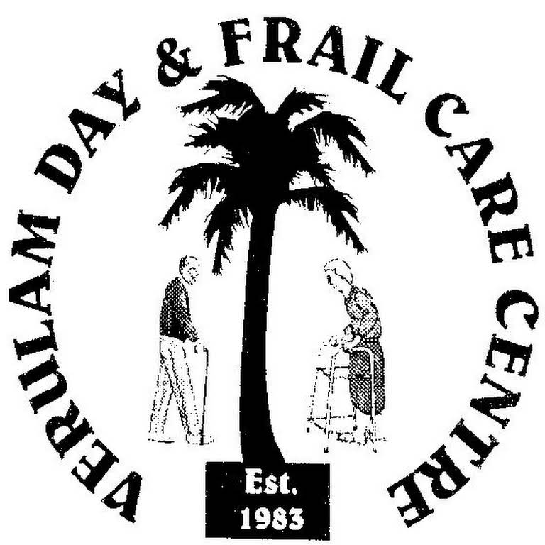

Home page:

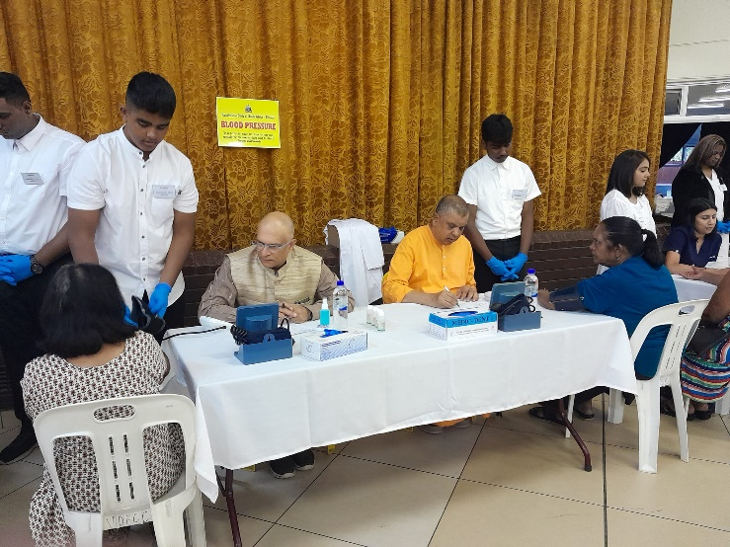

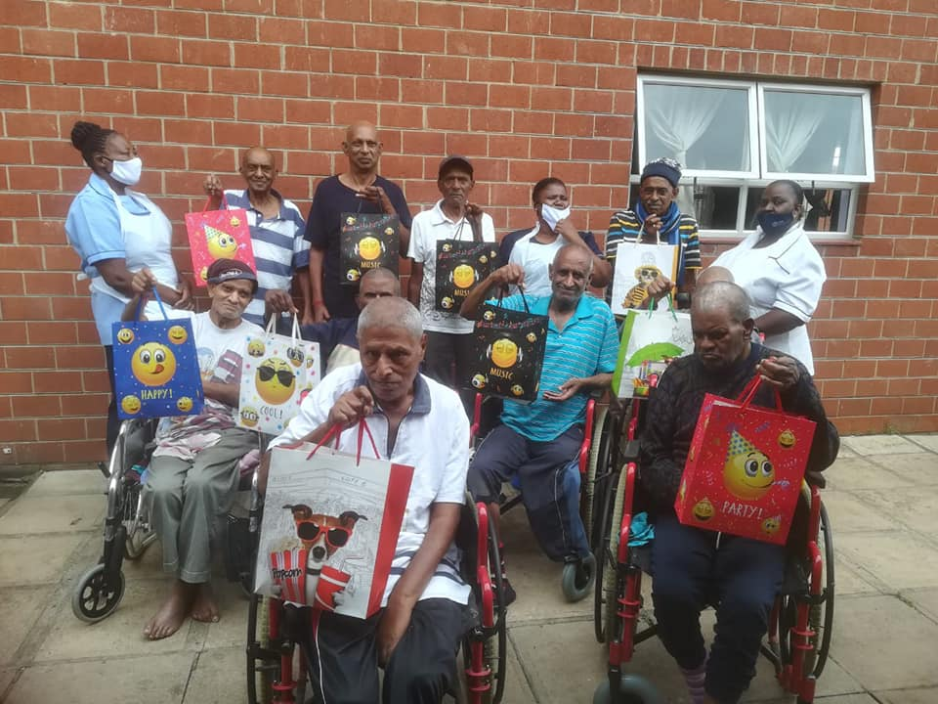

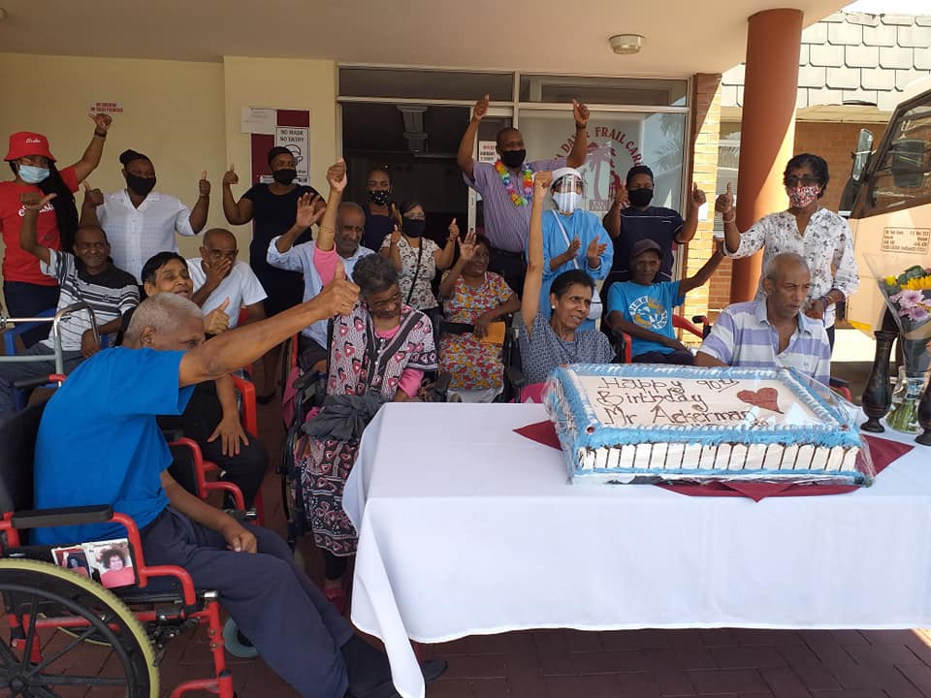

About us page:

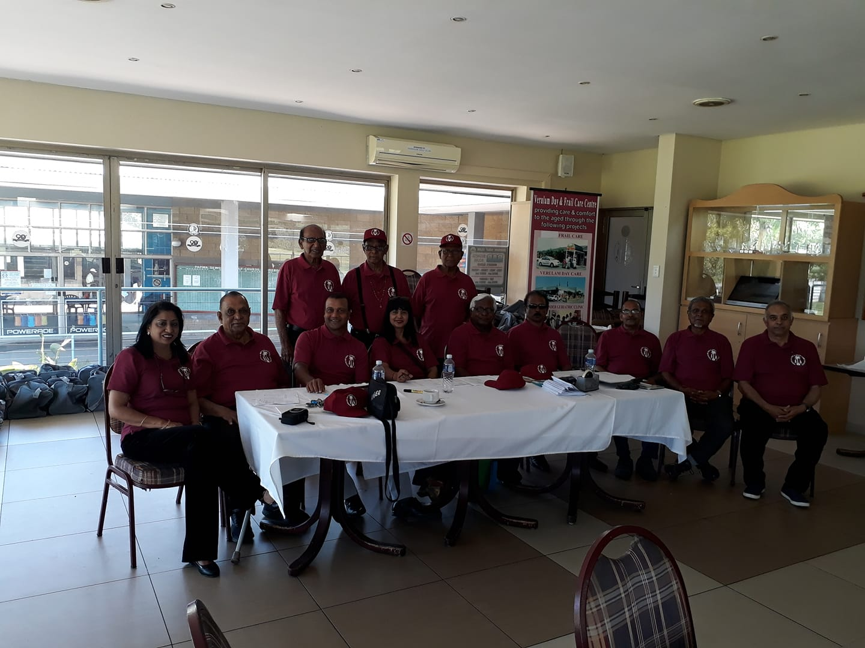

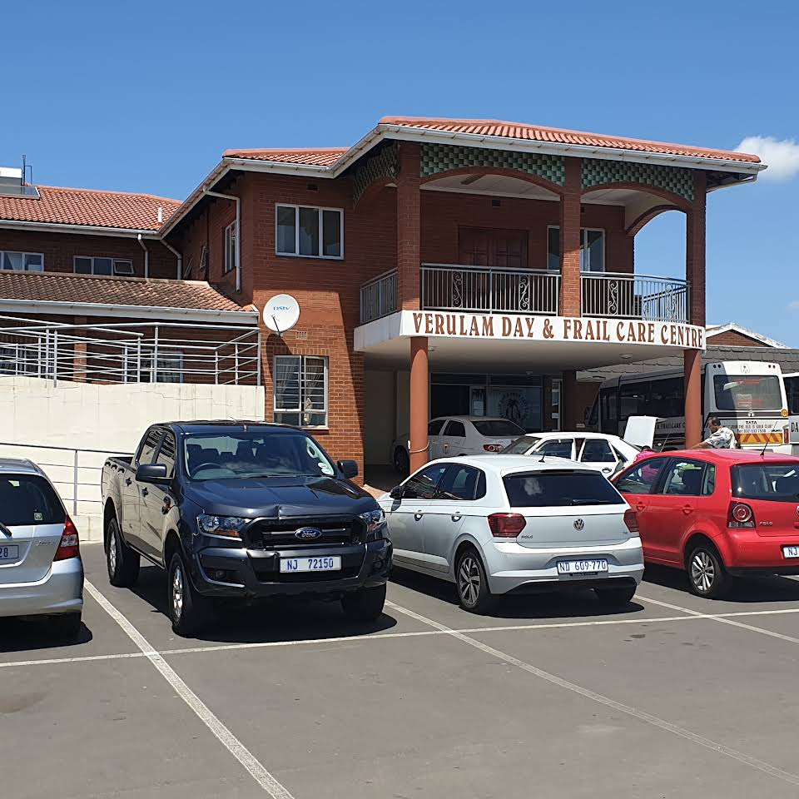

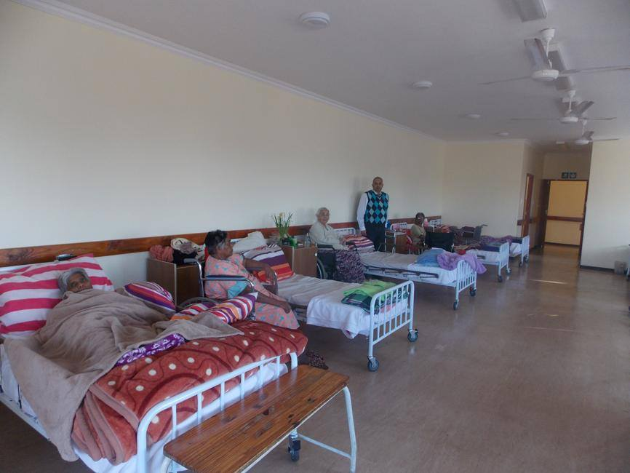

Services page:

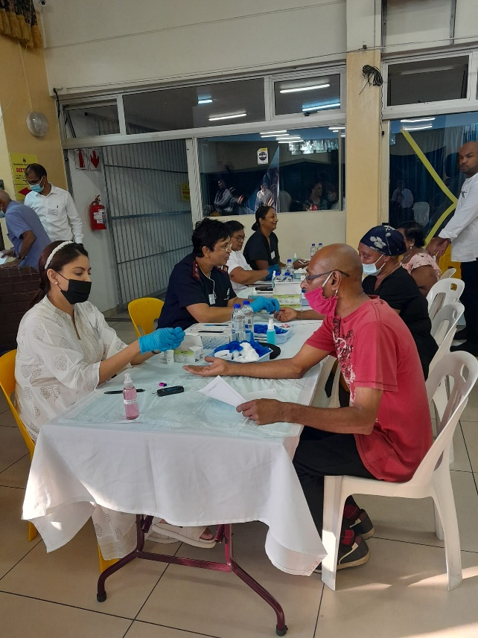

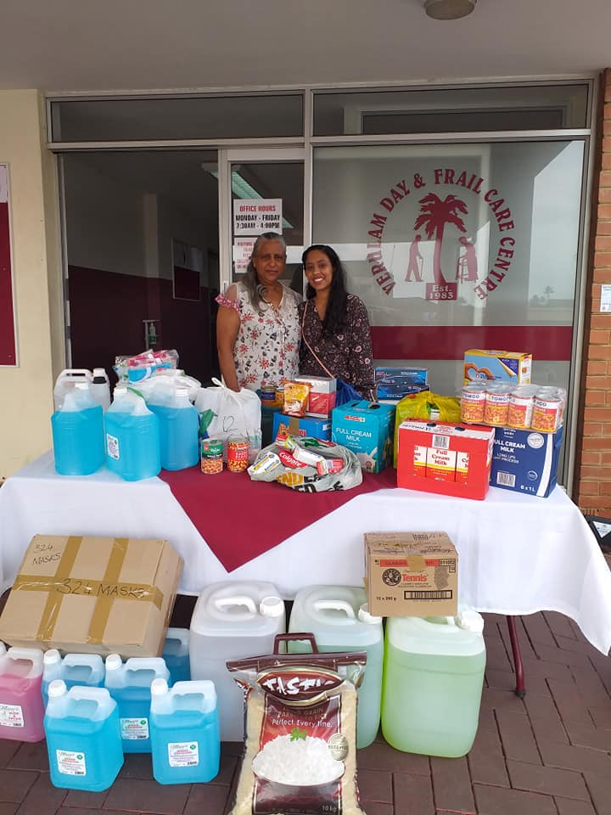

Donation page:

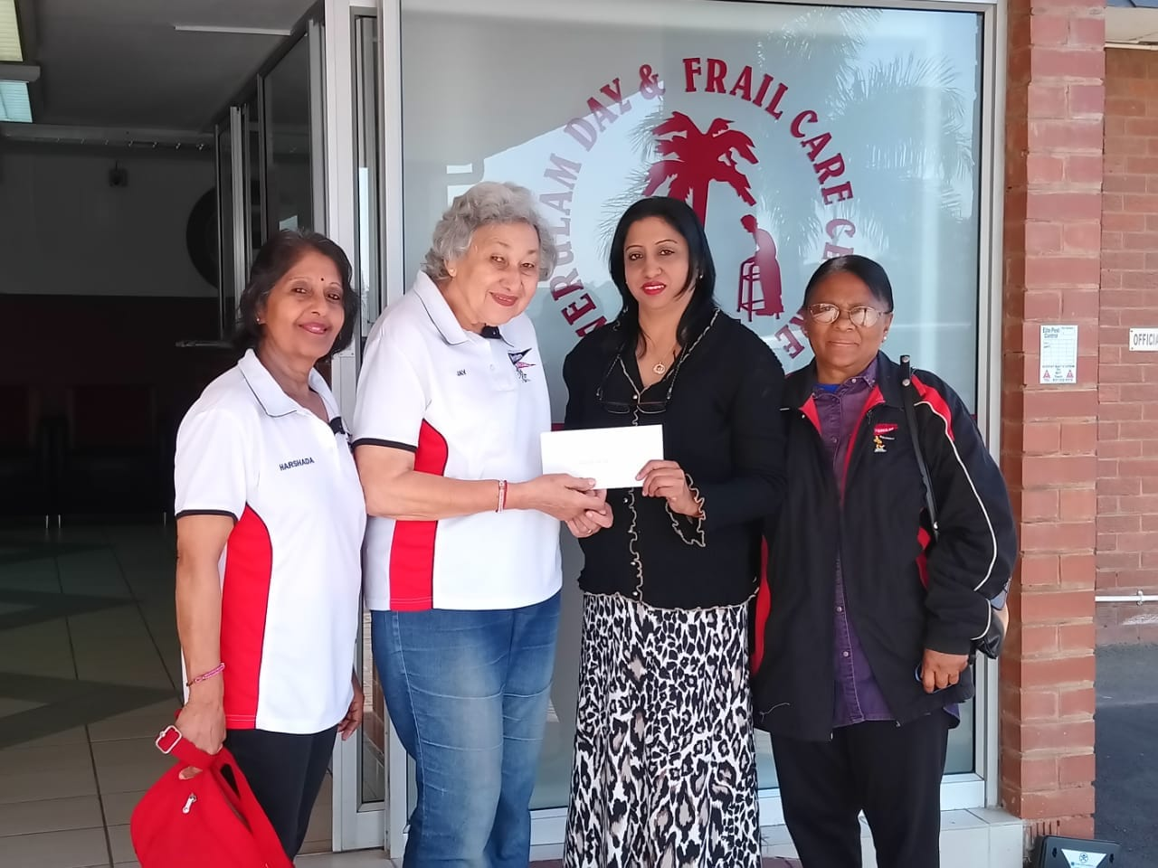

Website Pages and Content

1. Home page
   1. Logo
   2. Pictures
   3. Brief explanation of the organisations history and the services they offer together with the links to the respective pages
   4. Contact details
   5. Fundraising events
   6. Copyright / year
2. About us
   1. Picture of the organisations building
   2. Picture of the organisations team
   3. The NPOs history
   4. Vision and mission of the organisation
3. Contact page
   1. Telephone and cellphone number
   2. Email address
   3. Address
   4. Managers details
4. Services
   1. Pictures
5. Donation
   1. Information if people wish to be a volunteer
   2. Information on how to make a cash donation

References

(no date) *Aryan Benevolent Home*. Available at: https://abh.org.za/ (Accessed: March 28, 2023).

*Verulam Day & Frail Care Centre established in 1983* (no date) *Community Chest Durban*. Available at: https://www.communitychest.co.za/post/verulam-day-frail-care-centre (Accessed: March 29, 2023).

*Verulam Day and Frail Care Centre* (no date) *Non-Profit Organization in Brindhaven*. Available at: https://verulam-day-and-frail-care.business.site/ (Accessed: March 29, 2023).